**Big Mountain Ticket Pricing Model**

Currently, Big Mountain is operating with more premium amenities than Montana’s other ski resorts. As such, they are able to and have charged more for ticket prices at 81 dollars for an adult weekend lift ticket. According to a random forest regression model, there appears to be justification to charge even more for these tickets. The model can also be used to give guidance on proposed changes to the mountain’s infrastructure such as adding a chair lift; discontinuing several runs or adding additional snowmaking.

Running through collected data on ski resorts in the United States, there does not seem to be any patterns suggesting the resorts shouldn’t be treated as one market rather than grouped by state. Our pricing model was therefore created using data from all ski resorts in the country. This decision was made with no input from the marketing team and can be adjusted if needed.

The random forest regression performed the best of the two models tried. It beat the linear regression and is able to predict ticket price within less than 10 dollars. It predicted ticket price by weighing all the features at a given resort by importance in influencing ticket price. The graph below quickly shows which features have the most influence on ticket price. 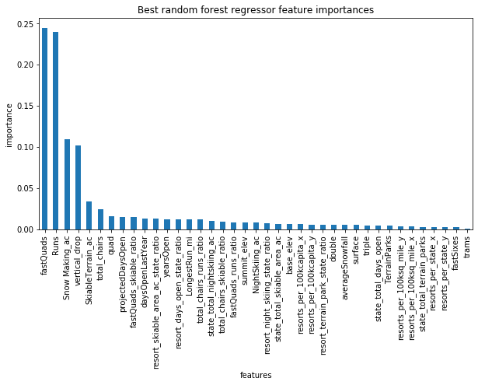

The model predicts Big Mountain’s ticket price as $90.85 with its current amenities. This price would increase revenue by $17500000. An increase of some price should be considered. However, this would put ticket prices even further above the rest of Montana’s ski resorts. More information could be provided and analysed to determine the price change.

**The proposed changes could affect ticket prices as follows:**

**Closing Runs**

Big Mountain has considered closing up to ten runs in order to save money without changing ticket prices. The uses the number of runs as an important determiner of ticket price. But some runs appear to be able to close without affecting predicted ticket price.

The graph below shows that closing a run won’t affect revenue much, but three would drop expected price significantly. It also shows that if three are closed, two more could be closed without affecting expected ticket price and that if six are closed, four more could be closed.

**Adding a Chair Lift**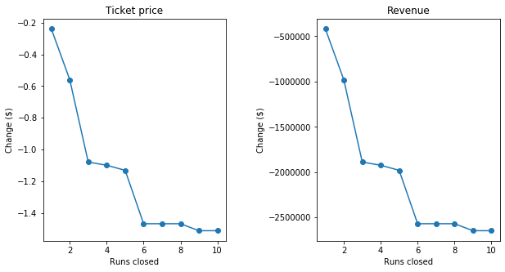

Consider adding a run, increasing the vertical drop by 150 feet, and installing an additional chair lift. Vertical drop, number of chair lifts, and number of runs are all considered fairly important by the model and indeed the model shows this justifies increasing ticket price by $0.84 potentially increasing revenue by $1463000. But the last chair lift installed at Big Mountain cost $1,540,000 to run so this alone does not appear to be a cost effective change.

**Adding Two Acres of Snowmaking**

Consider the previous change with an additional two acres of snow making added. Snow making as an influential feature in the model, but this small amount did nothing to change predicted ticket price in the model.

**Increasing the Longest Run**

Increasing the longest run by .2 miles and adding 4 acres of snowmaking shows no significant change in predicted ticket price.

**Conclusion**

There seems to be justification for Big Mountain to increase ticket prices without making changes to amenities. Lowering operating costs by closing runs appears to be the most effective of the proposed changes to the resort. But data on the cost of operating runs would be essential for running a cost/benefit analysis to determine how many to close.

The model could potentially change with more data such as proximity to major airports and cities or participation in cooperative ski passes. More information could lead to more accurate price predictions. But it should be useful to run quick analysis on proposed infrastructure changes.